**Introduction:**

We, as a group, were given the task to make a website. The client wanted a website based on the topic of tips and resources about “How to study or revise from home”. This topic would’ve come up quite recently considering the “Covid-19 Pandemic”. The website will contain 5 pages, the “homepage”, the “tips” page, the “survey” page, the “game” page and the “about us “ page. While the majority of the pages are pretty self-explanatory, the “about us ” page will contain content from people who have experienced studying and revising from home.

**Mood board:**

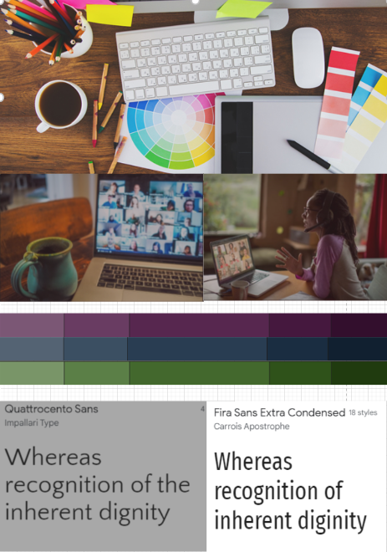

**Wire Frames:**

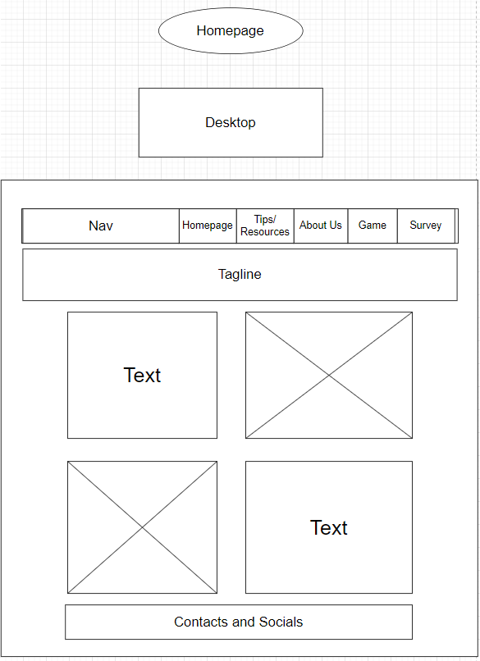

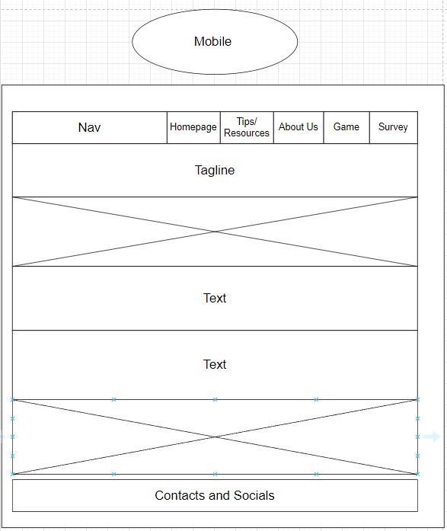

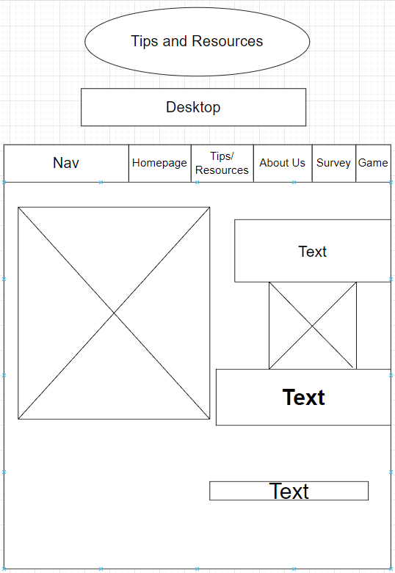

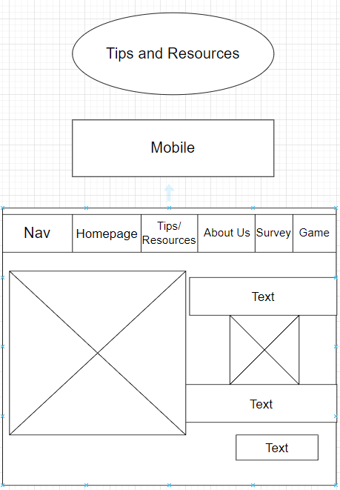

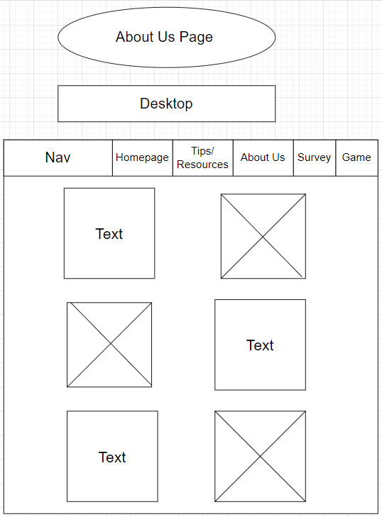

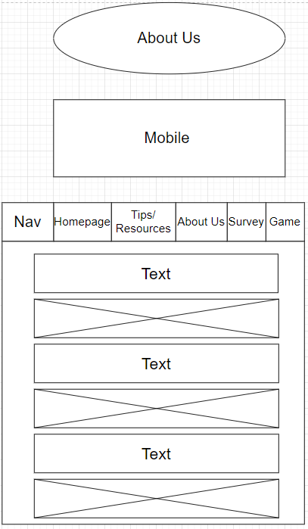

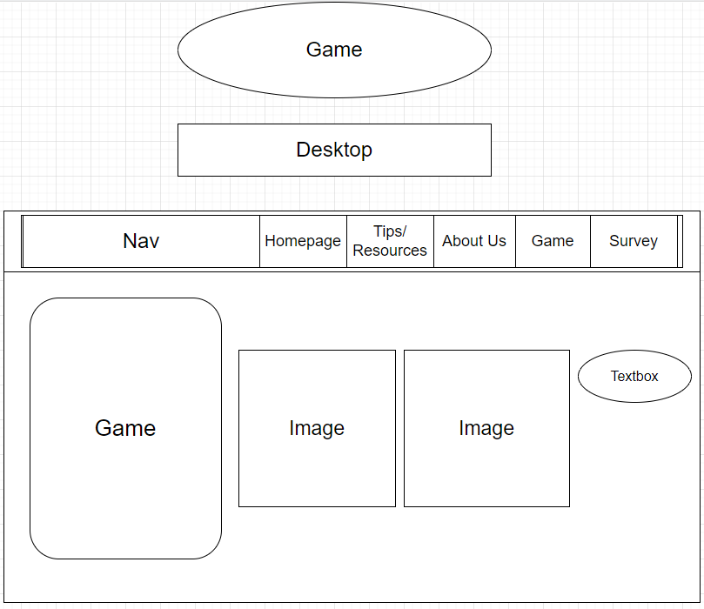

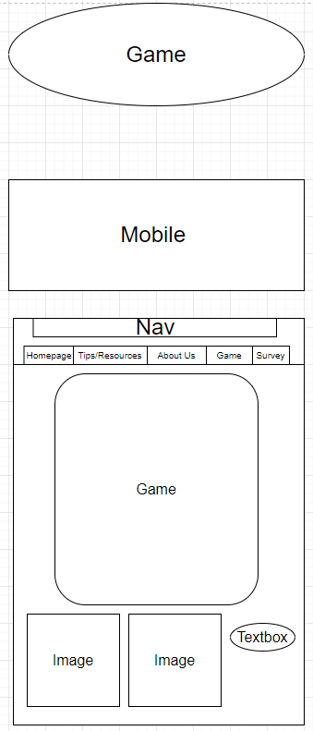

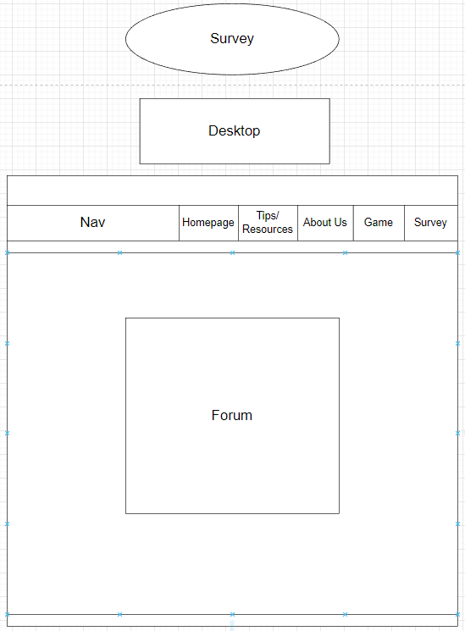

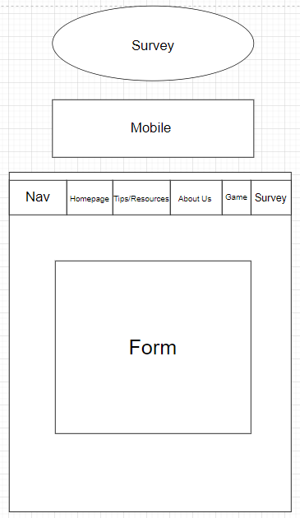

**Sitemap:**

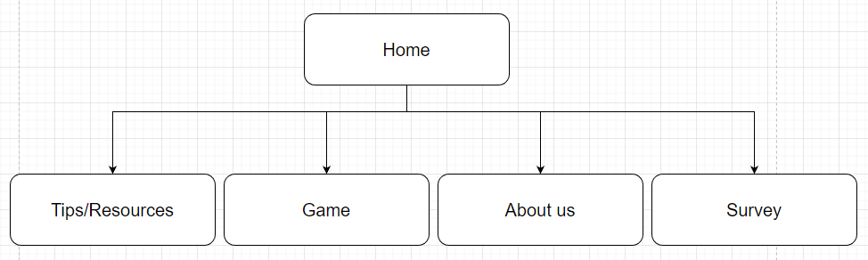

**Team Members Listed in Report and tasks carried out in the group project:**

|  |  |
| --- | --- |
| Craig Murphy | Homepage  Survey/Form page  Video Presentation |
| David Gevorkyan | Game page |
| Rediet Berhe | Tips and Resources page  About Us Page |

**Craig Murphy:**

I found making the Homepage and Survey/Form pages quite fun. Experimenting with different colours and backgrounds. The area where I ran into real difficulty was responsiveness. We agreed on making the responsiveness for this website on mobile to be at 415px. Even with Bootstrap, I ran into real difficulty trying to make the page turn out the way it was planned in the wireframe on mobile. It turned out that that I was using a CSS file in another folder and trying to target the HTML file that was in our Project folder. I’ve learned from this mistake to always check my file paths to show what I’m working on at all times.

<http://idk.great-site.net/indexhomepage.html?i=1>

**David Gevorkyan:**

First, I had to decide what game I was going to develop for our website. After consulting with my group members, I chose hangman.

After choosing the game I had to come up with a rough sketch of how it is going to work. I decided to have multiple <p> tags that are going to contain the letters of the word.

I wrote a script to count how many letters the random word has and create that amount of <p> elements. I assigned tags to those <p> elements using the variable in the for loop that was creating them, which made accessing them easier. Then the code converted the secret word to an array of letters and make a for loop to check a letters presence in the word, so that I could compare players input to the letters of the word.

Also, I made the code to choose a random word from an array of words. Then I added lifes so that the player would lose If he ran out of guesses.

And so that all this would work I had a text area for the input, from which my script was getting the players input and a submit button which was triggering the function responsible for checking and revealing the letters.

I topped it off by adding some more features like a reload button, a <p> tag that would show the player all the wrong letters that were already guessed, a hangman image that changed after every wrong guess, and an executioner image that would comment the game.

Rediet Berhe:

In this project, I have learned a lot and managed to work on my own, which is very important for me. I made the about us and tips/resources pages, it was a bit challenging but with the help of the group members we managed to link the pages together and position the texts and images as planned. The most challenge I faced was getting the page to be responsive to fit mobile resolution. It finally worked for me, yay. From this group project, I learned how to create my own webpage and deploy it. This project will help me in the future throughout the time I am in college and after I graduated too. Thanks to our tutor Emer, we had all the support we can get.